**Functions**

Function is a collection of statements which perform an operation.

To define a function we use "def" keyword.

To call a function we use function name.

The Function which is defined for 1 time can call for multiple times.

**Syntax and parts**

**Examples**

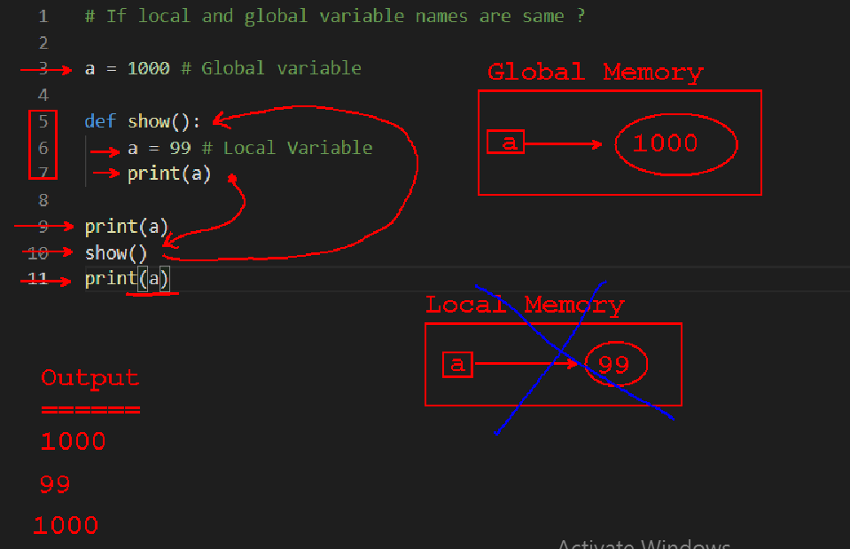

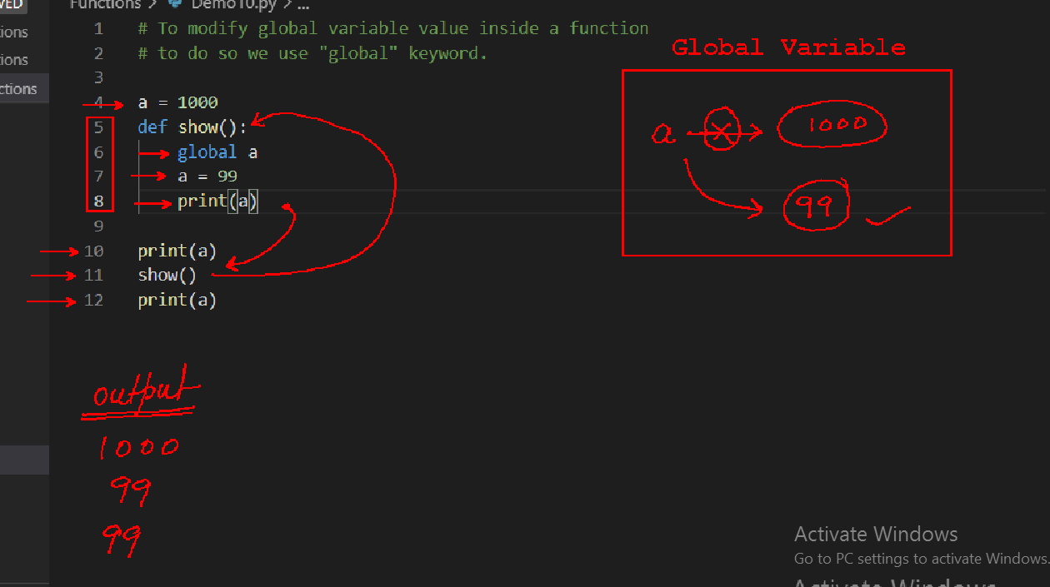

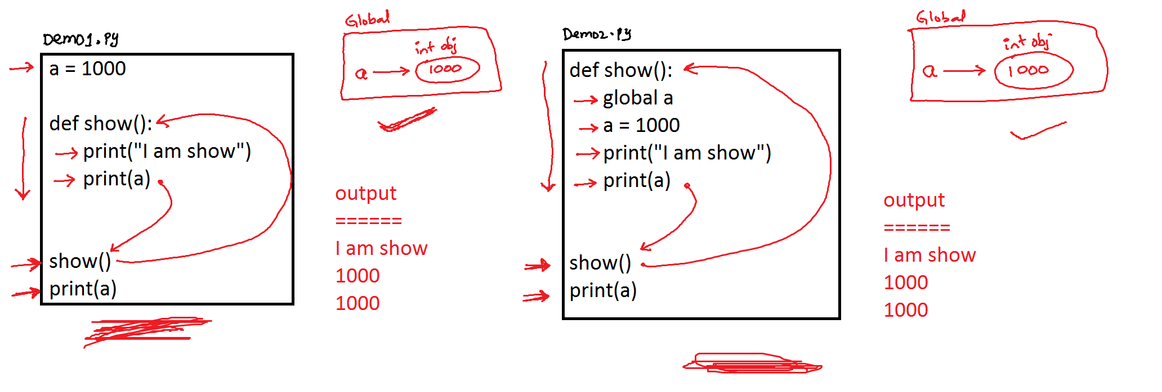

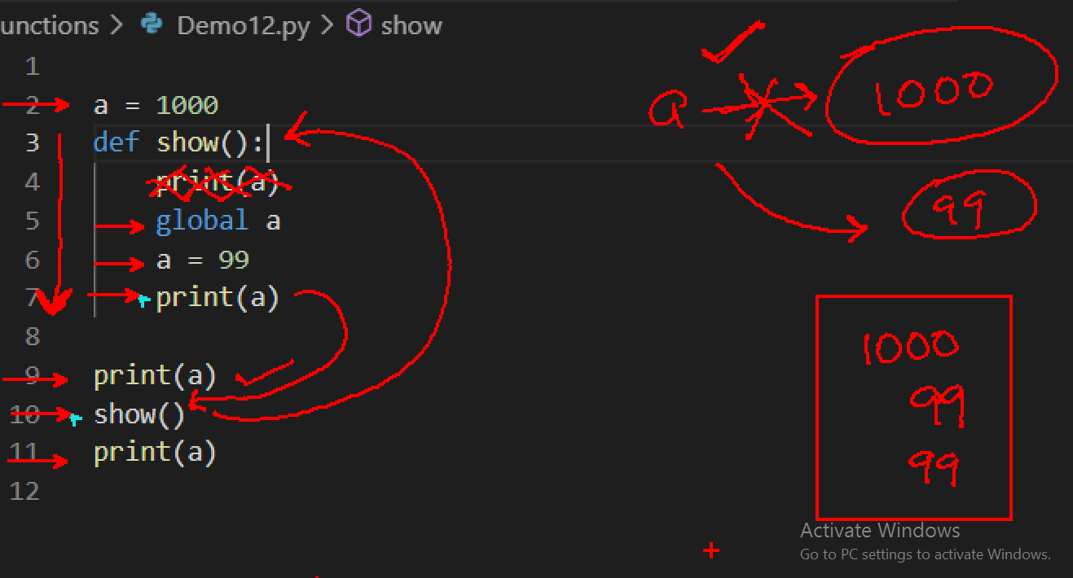

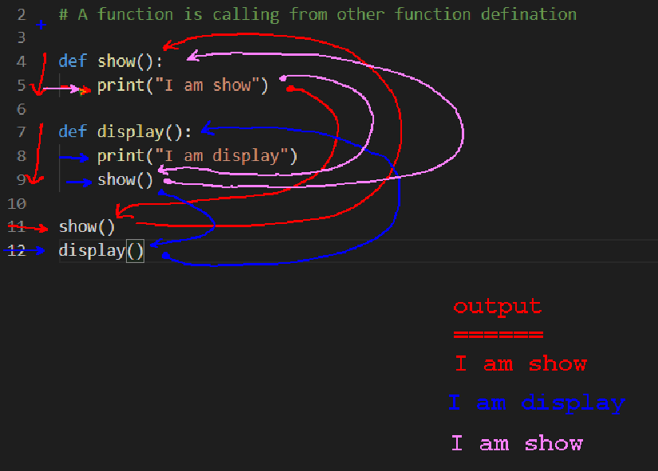

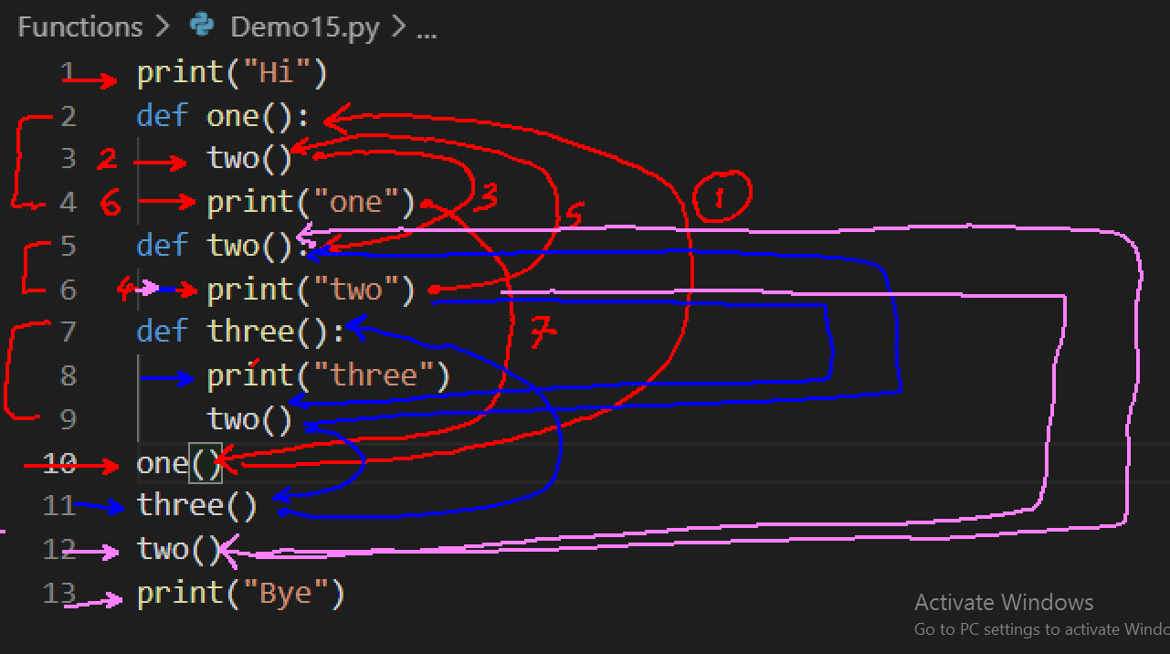

Parameter

In python we can define functions in 4 ways.

1) Function without parameter and without return (0,0)

2) Function with parameter and without return(1,0)

3) Function without parameter and with return.(0,1)

4) Function with parameter and with return.(1,1)